Report of Motor Controller and Motor Efficiency Calculations

Zainab Hussein

May 4, 2017



Table of Contents

**Calculation of Efficiency1**

**Plots of Efficiency2**

**Future Work 3**

# Calculation of Efficiency

Output mechanical power is calculated from the product of load torque (Nm) and motor speed (rad/s). Input electrical power is calculated from the product of supply current (A) and supply voltage (V). In figure 1, supply current is IDC, supply voltage is VMC, load torque is τ and motor speed is ω. Efficiency is the ratio of mechanical power and electrical power shown in Eq.1

$η=\frac{P_{OUT}}{P_{IN}}=\frac{τω}{iv}$ Eq.1

Where η is efficiency, τ is load torque (Nm), ω is motor speed (rad/s), i is supply current (A) and v is supply voltage (V)

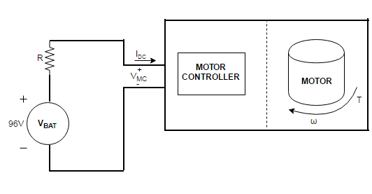

Figure 1 Power supply and motor controller and motor system

# Plots of Efficiency

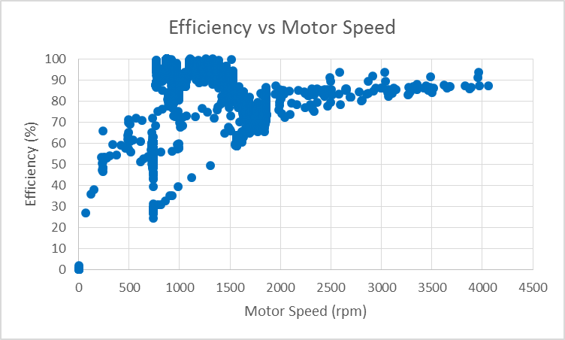

Transient-like behavior

Figure 2 MCM efficiency vs motor speed

Generally the efficiency increases with increase in motor speed.

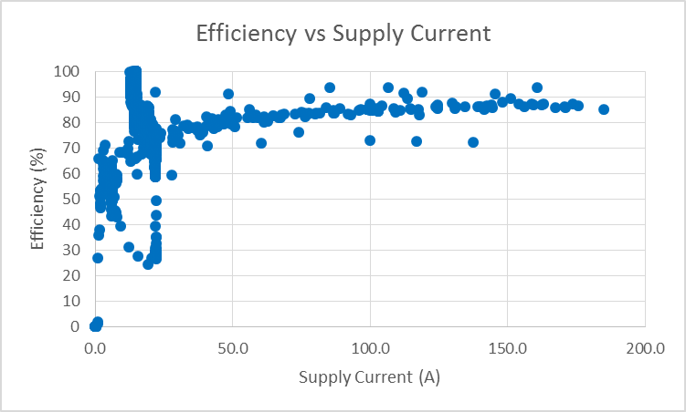

Transient-like behavior

Figure 3 MCM efficiency vs supply current

Generally the efficiency increases with increase in supply current.

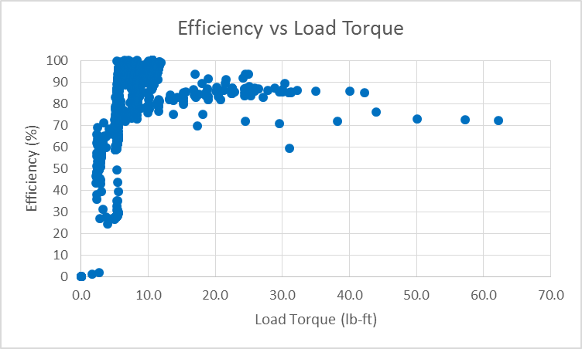

Transient-like behavior

Figure 4 MCM efficiency vs load torque

Generally the efficiency increases with increase in load torque, around 25 lb-ft the efficiency starts decreasing.

The transient-like behavior in figure 2-4 are possibly caused by two reasons:

* Motor is unstable at the given physical parameter low range. A possible approach to this is to set the working range of the motor and motor controller excluding the transient region.
* Data source for this plot is the lookup table1 consisting of combined data collected in spring 2017 and spring 2016. Experimental data from spring 2017 had irregularities cleaned. However, spring 2016 is used as raw data, which could have had irregularities that had not been collected.

# Future Work

Investigate the reason for the transient behavior, and the significance this has to the Lafayette Formula Electric car.

# Reference

1Hussein, Zainab. *Car Speed and MCM Efficiency Calculations Spreadsheet*. May 3, 2017